Name: Aaron Modiyil Joseph

Data Source: [World Economic Outlook Database](https://www.imf.org/en/Publications/WEO/weo-database/2022/October)

Link to my GitHub Repo: [aaronmj7/Assignment-1-Visualisation-ADS1](https://github.com/aaronmj7/Assignment-1-Visualisation-ADS1)

**Applied Data Science 1**

**Assignment 1: Visualisation**

# Visualisation 1: Evolution of Consumer Price Index for G7 Countries

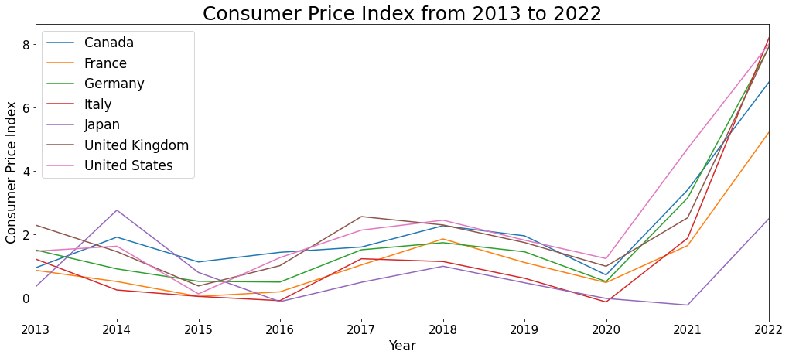

A line plot is an effective method to illustrate how the Consumer Price Index (CPI) has changed over time.

Evolution of CPI of the G7 countries, 7 major economies of the world, from 2013 to 2022 is shown in the plot. Consumer price index is defined as the change in the prices of a basket of goods and services that are typically purchased by specific groups of households. The line plot exhibits fluctuations until the year 2020, after which it increased dramatically, possibly due to the COVID-19 pandemic.

# Visualisation 2: Unemployment Rate of G7 Countries in 2000 and 2020

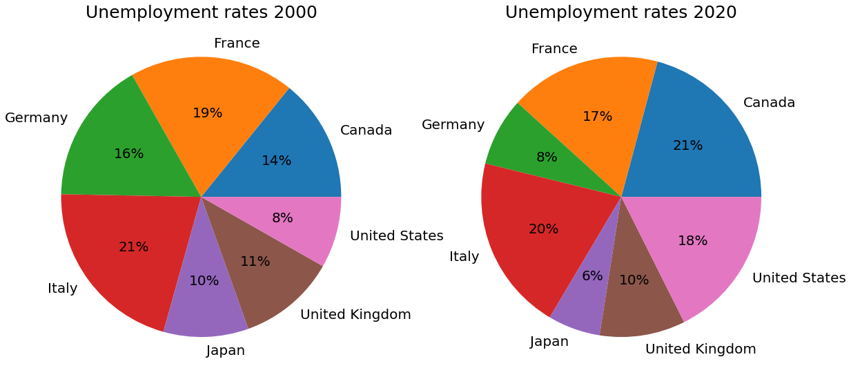

Pie plots are an effective way to compare the relative rate and show the shift over time.

The two pie plots illustrate the unemployment rate of G7 countries in the years 2000 and 2020. Unemployment rate is the number of unemployed people divided by the economically active population. Over the two decades, the relative rate nearly doubled for United States and Canada, while it almost halved for Japan and Germany.

# Visualisation 3: Unemployment Rate of G7 Countries in 2022

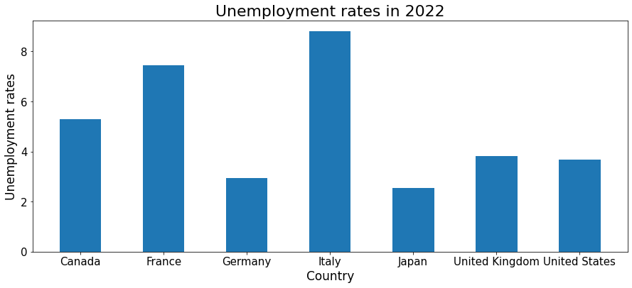

A bar plot is a good way to visualize how a particular indicator varies among different countries.

The bar chart displays the unemployment rates of the G7 countries in the year 2022. Italy, France and Canada have high rates whereas Germany, Japan, UK and US have comparatively lower unemployment rates.